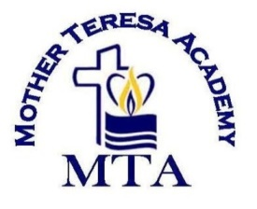

Fundraising Letter

Dear Parents,

Mother Teresa Academy has been a positive light in our community for fifteen years. Our school has grown and thrived for this many years through your fundraising efforts. Our school is a non-profit private school so we do not receive any funding from the state or school district. Your fundraising efforts help bridge the gap between tuition and expenses. In the past, your fundraising efforts have helped fund our new playground, field trips, and bring new experiences to our school. We are asking that you help continue to make our school better and help us to grow. Please sign the bottom of this form agreeing to commit to helping us fundraise this year. Thank you for your continued effort to improve our school and give the children the best school experience possible!

I agree to participate in the school fundraisers this year to help my student have the best school year possible.

_______________________ _____________________
Parent Signature Date

_______________________ _____________________
Parent Signature Date

